**LESSON GUIDE FOR TOP CLASS LANGUAGE**

**TERM ONE 2023**

WK ONE ORIENTATION

**Lesson 1 – 5**

Oral question / self introduction

ie -What is your name?

-Where do you live?

-In which class are you?

**WEEK TWO**

**LESSON (1) Our Alphabet**

Copy and write the letters a - e

a b c d e

\_\_\_ \_\_\_ \_\_\_ \_\_\_ \_\_\_

\_\_\_ \_\_\_ \_\_\_ \_\_\_ \_\_\_

\_\_\_ \_\_\_ \_\_\_ \_\_\_ \_\_\_

**Lesson two Our Alphabet**

Write the letters correctly

f g h i j

\_\_\_ \_\_\_ \_\_\_ \_\_\_ \_\_\_

\_\_\_ \_\_\_ \_\_\_ \_\_\_ \_\_\_

**LESSON (3) Our Alphabet**

Copy and write letters K – O

k l m n o

\_\_\_ \_\_\_ \_\_\_ \_\_\_ \_\_\_

\_\_\_ \_\_\_ \_\_\_ \_\_\_ \_\_\_

**LESSON (4) Our Alphabet**

Write the letters p – t

P q r s t

\_\_\_ \_\_\_ \_\_\_ \_\_\_ \_\_\_

\_\_\_ \_\_\_ \_\_\_ \_\_\_ \_\_\_

**Lesson (5) Our Alphabet**

Learn the letters and write

u v w x y z

\_\_\_ \_\_\_ \_\_\_ \_\_\_ \_\_\_ \_\_\_

\_\_\_ \_\_\_ \_\_\_ \_\_\_ \_\_\_ \_\_\_

**WEEK THREE**

**Lesson (1) Our Alphabet**

Listen and write the letters

e m k q d

g p a x r

**Lesson (2) Our Alphabet**

Write correctly





**Lesson (3) Our Alphabet**

Fill in the missing letters

a b \_\_ d\_\_\_f

d e \_\_\_ \_\_\_ \_\_\_

k \_\_\_ m \_\_\_ p

**Lesson (4)**

Write the missing letters

 \_\_ \_\_\_ \_\_\_ t

v w \_\_\_ \_\_\_ z

j \_\_\_ \_\_\_ m n

**Lesson (5)**

Find my way home

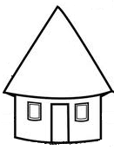 b

m a c

l d e

k i f

j h g

**WEEK FOUR**

Lesson (1) Vocabulary

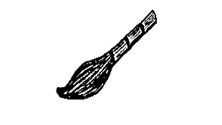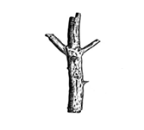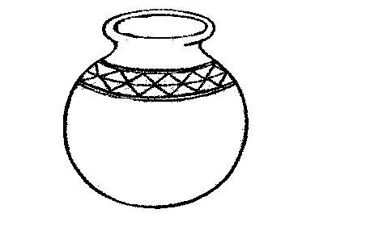Write the first letter for the given picture

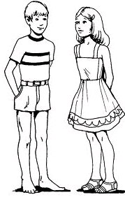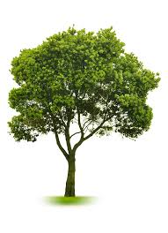



**Lesson 2 Our Alphabet**

Join the dots correctly

r

 Z

y s

t

x v

 w

**Lesson (3) Our Alphabet**

Write the next letters

a b c

f g

k l m

s t

Lesson (4) **Our Alphabet**

Write the next letters

m d

p x

a s

**Lesson(5) Vocabulary**

Read and draw good pictures

axe egg

bag hut

cat fish

**WEEK FIVE**

LESSON (I)

Write the middle letters

a d r u w z

k m f h

**Lesson (2) vocabulary**

Circle the words for the given letter

m mat moon pot

a tin axe ant

t tap sun tree

**Lesson (3) Our Alphabet**

Write the letter before

b c d t  **u** v

f g h l m n

y z j k

Lesson (4) **Vocabulary**

Write the letter before

Z y , z

d q , r

**Lesson (5) Vocabulary**

Match pictures to words

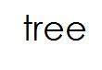 

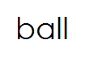



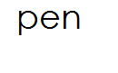



**WEEK SIX Vocabulary**

LESSON (1)

Read and draw

moon stick

book girl

broom pen

**Lesson (2)**

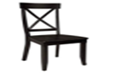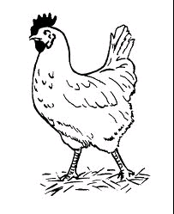Name the pictures

**Lesson (3)**

Arrange the letter in order

c , a , b, , ,   
e , d, f , ,

i, h, g , ,

Lesson (4)

Arrange the letters in order

y , x , z r , p , q

, , , ,

o , n , m w , v , u

, , , ,

**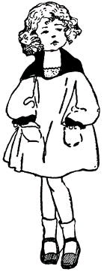Lesson (5) Vocabulary**

Write the missing letters

d um h u se g rl

[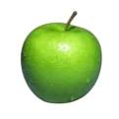](http://www.google.co.ug/imgres?imgurl=http://styletips101.com/wp-content/uploads/2008/10/apple.jpg&imgrefurl=http://styletips101.com/fashion-tips/how-to-dress-for-your-shape.html&usg=__TMOEr80mAtsyICw8QQCmjFSenJ4=&h=359&w=359&sz=14&hl=en&start=14&zoom=1&tbnid=M0Mg-1z8dKg67M:&tbnh=121&tbnw=121&ei=lPNOT-L6LIiO0AWknI3zCw&prev=/search?q=apple&um=1&hl=en&sa=N&gbv=2&tbm=isch&um=1&itbs=1)fd00586_

gl ss appl

**WEEK SEVEN**

**Lesson (1) Structures**

Complete these sentences using (It is a ……….)

fd00586_ It is a glass.



It is a ­\_\_\_\_\_\_\_\_\_\_\_\_\_\_

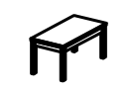

It is a \_\_\_\_\_\_\_\_\_\_\_\_\_

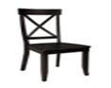

It is a \_\_\_\_\_\_\_\_\_\_\_\_\_\_

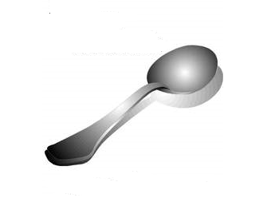

It is a \_\_\_\_\_\_\_\_\_\_\_\_\_\_\_

**Lesson (2) Structures**

Read and draw

This is a broom \_\_\_\_\_\_\_\_\_\_\_\_\_  
This is a girl \_\_\_\_\_\_\_\_\_\_\_\_\_\_

This a pencil \_\_\_\_\_\_\_\_\_\_\_\_\_\_  
This a flower \_\_\_\_\_\_\_\_\_\_\_\_\_\_  
**Lesson (3) Structures**

Complete the sentences.

I can see the \_\_\_\_\_\_\_\_\_

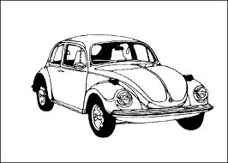I can see an \_\_\_\_\_\_\_\_\_

I can see a \_\_\_\_\_\_\_\_\_

**Lesson (4) Structures**

Make sentences using. (Here is a …………..)



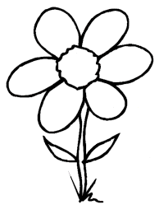

**Lesson 5 Structures**

Make good sentences using (Look at the ……..)



[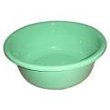](http://www.google.co.ug/imgres?imgurl=http://www.honrygroup.com/Plastic_Basin.jpg&imgrefurl=http://www.honrygroup.com/Honry-Links%20Your%20Plastic%20Materials.html&usg=__CgWEkmpZNapUSe3nQxJvTR-K8m4=&h=360&w=360&sz=15&hl=en&start=1&zoom=1&tbnid=qX99uOjvkK6thM:&tbnh=121&tbnw=121&ei=VJa2TcadOMedOtC-0JEP&prev=/search?q=plastic+basin&hl=en&sa=N&gbv=2&tbm=isch&itbs=1)

**WEEK EIGHT**

**LESSON (1) Structures**

Read and draw

Here is a duck

It is a bench

I can see a fish

This is a bench

Look at the star

**Lesson (2)**

Question of the 5ws

What is your name?

What is this?

What is the colour of your hair / uniform?

What can you see?

**Lesson (3)**

Who is your friend?

Who are your teachers?

Who is the owner of this bag / pen / book?

Who is this?

**Lesson (4)**

Where do you go to school?

Where do you live?

Where are you going?

Where is my book?

Where is your school found?

**Lesson (5)**

When do go to sleep / bed / home?

Why do you come to school?

Which colour are you eyes / uniform?

In which class are you?

How do you come to school?

**WEEK NINE Colours**

**LESSON (1)**

Read and shade the colour

red yellow

green blue

black

**Lesson (2) Colours**

Learn the colour and match to the word.

Orange

black

white

pink

Lesson (3) **Colours**

Colour and name correctly.

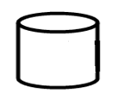



**Lesson four Colours**

F1 Write the colour name





**Lesson (5) Colours**

Fill in the missing letter for the colour name

r d bl e gr y gr n

yell w bl ck